Introduction to Our Solar Siblings
(A video introduction to Our Solar Siblings is available via this link, it is advisable to watch the video first! Our website is www.oursolarsiblings.com)
Welcome to the high school astronomy education project, Our Solar Siblings! In partnership with Las Cumbres Observatory Global Telescope Network, we provide access to a growing network of 18 research telescopes at 6 top astronomical sites around the world for teachers and students to use in their classrooms. The core focus of this project is Year 10 students covering the astronomy content of the Australian Curriculum in their classrooms. While this is technically our focus, we happily provide materials, telescope time and support for Year 11 and 12 as well as supporting many forms of independent research projects and school science or astronomy clubs. We also can support international users as well as those countries or states which do have astronomy in their high school curriculum are likely to have a lot of commonalities with the Australian curriculum. If you would like to contact us about anything to do with Our Solar Siblings (or beyond!), please contact Michael Fitzgerald at mfitzasp@gmail.com.
This distribution contains all of the curriculum and support materials for Our Solar Siblings. There are three folders containing each of the “Projects” discussed in more detail below, one folder containing the software potentially used and another folder containing publications about Our Solar Siblings in the literature. The software is discussed in more detail in the Project 1 manual, which is available here. The organisation of the three projects are discussed in more detail below.

Curriculum Materials
We provide teachers with a set of curriculum materials that is organised into a sensible, scaffolding and coherent flow of classes. They are split into three separate projects. The broad contents are displayed in the table below.
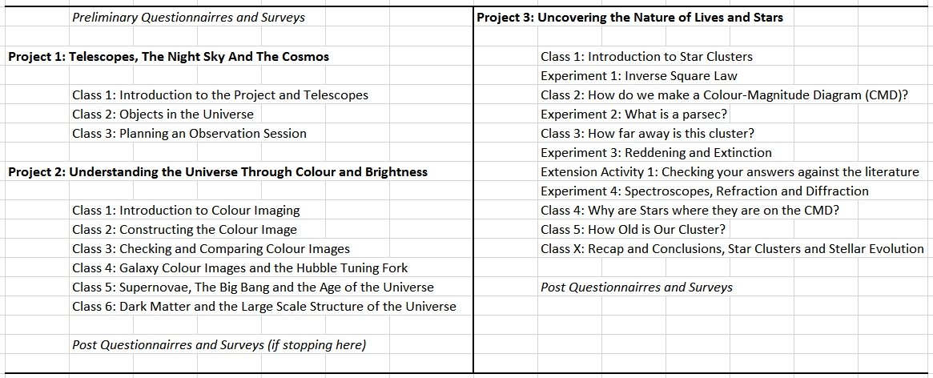
The first project is Telescopes, the Night Sky and the Cosmos. This project introduces students to telescopes, the variety of aesthetically pleasing objects they can see in the night sky, to pick an object of their own choice to be observed at one of the telescopes. This is essentially the introductory project forming the scaffolding for the second and third projects.
The second project is Understanding the Universe Through Colour and Brightness. The vast majority of the information about the universe beyond our solar system has come in the form of the colour and brightness of light. Students begin their exploration by creating and comparing their own colour images that they create from actual data of various objects that they have requested from the telescopes. The students then learn about the colour, brightness, size and shape of galaxies in the form of creating their own Hubble Tuning Fork diagram. We then explore Supernovae in distant galaxies to understand the big bang, dark energy and calculate the age of the Universe. The students further expand their understanding by exploring galaxy rotation, dark matter and how galaxies are distributed across the universe.
Combining the first two projects forms a coherent, flowing set of scaffolded inquiry-based activities that address the core content of the Year 10 Australian Curriculum. We have done our best to make the shortest set of coherent inquiry-based data-driven activities that clearly addresses the curriculum content “Science Understanding” statement with approaches that address the many of the “Science Inquiry Skills”. We provide some approaches to address the “Science as a Human Endeavour” curriculum strand in parallel to the content. Our philosophy has been to provide a bit more than is necessary and then let the teachers decide what to use, what to delete or what to expand upon. This is based on knowing that it is far easier to delete a powerpoint slide, remove unwanted sections or skip entirely past an existing activity than to have to find or write one from scratch.
With that in mind, the first time a teacher implements the Our Solar Siblings materials, they might just like to get the students to explore what objects are in the night sky, pick an object, get some images from the telescope and make a pretty colour picture. This perhaps could be embedded into their current materials and approach they already use and year after year, a little more of the Our Solar Siblings materials could be incorporated. Another equally valid approach could be to start using the Our Solar Siblings materials, with modifications and removals in order to fit into the school programme, from start to finish. We have designed the curriculum materials to facilitate either approach.
The third project, Uncovering the Nature and Lives of Stars, builds upon the first two projects. It explores the evolution, lifecycles and properties of stars through a data-based inquiry based approach following a similar process that a scientist may undertake. The process not only teaches students the content knowledge about stars but also develops an understanding of how scientists come to know such things through the use of data. The third project is also a near perfect fit to the International Baccalaureate astrophysics curriculum as well as the previous NSW senior physics Cosmic Engine and Astrophysics option. There is no explicit astronomy in the Year 11 and 12 Australian Curriculum, which is surprising considering astronomy is one of our scientific research strengths and was the source of a recent Australian Nobel Prize. As yet, it isn’t clear how states will finally interpret this curriculum with some states perhaps retaining some astronomy content.
Students who move through this third project gain skills that can be used to undertake an authentic scientific independent research project utilising the LCOGT telescopes. Some of these projects have reached the stage where their findings were published in actual scientific journals. There are currently more research projects being written up for publication. It is also useful for school astronomy or science clubs who may like to undertake a long-term collaborative research project. At this level, we provide direct support, training and mentoring to the students and their teacher through the research project generally online and also through school visits.
This was a very broad overview of the curriculum materials and approach we take in Our Solar Siblings. If you have any questions at any time, want to organise a school visit or have any suggestions, please contact Michael Fitzgerald at mfitzasp@gmail.com. We are happy to support any usage, big or small, long or short, of our materials and telescope time to help students in understanding or appreciating the universe!

